Types of Unsupervised Learning
1.Clustering
2.Association

clustering is an unsupervised learning which involves which involves grouping the similar data points
example-

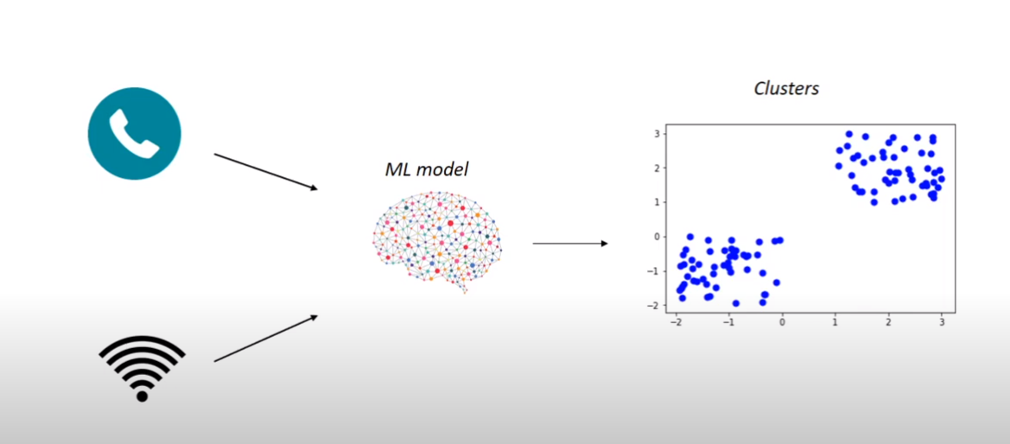
we are provided with customer data from telecom
from above lets say two clusters are formed 1st is of those customer who have high internet usage and less call usage and more internet usage and other cluster is that less internet and more call.
So company can provide offer to customer (wrt to their cluster)

regression is an unsupervised learning which involves finding important relationship between data points.
Unsupervised Learning Algorithm:
1.K-Means Clustering
2.Hierarchical Clustering
3.Principal Component Analysis(PCA)
4.Apriori
5.Eclat

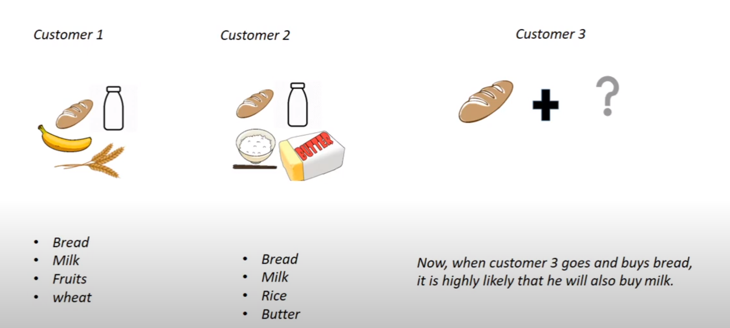
example of regression:

